

**University of Barishal**

**Report On**

**Topic*: Customer Purchasing Behavior: Trends and Insights"***

**EDGE-BU-CSE**

**Name:**Habiba Jahan Rumi

**Roll:01-43-25**

Department: **Management Studies**

**Name**: Md. Erfan

**Designation:** Assistant Professor & Chairman Department of CSE

**Cell No**. 01799598455

**Email**: irfan.bucse@gmail.com

**Date 0f Submission:06-12-2024**

Table of Contents

|  |  |  |
| --- | --- | --- |
| SL NO. | TOPIC | PAGE NO |
| 1 | EXECUTIVE SUMMARY | 3 |
| 2 | INTRODUCTION | 4 |
| 3 | LITERATURE REVIEW | 5-8 |
| 4 | METHODOLOGY | 8-9 |
| 5 | FINDINGS/ANALYSIS | 9-12 |
| 6 | REFFERENCE | 12 |
| 7 | APPENDIX | 12-13 |

* **Executive Summary**

This report analyzes customer purchasing behavior across various dimensions such as seasonal trends, gender preferences, and shipping methods. Key recommendations include optimizing shipping options and tailoring marketing strategies to demographic patterns."

The findings reveal that electronics and apparel dominate holiday purchases, while home goods see a spike in spring. Faster delivery options significantly boost customer satisfaction, particularly for younger age groups. Digital wallets and credit cards emerge as the most preferred payment methods, while discounts strongly influence review ratings.

To capitalize on these insights, we recommend increasing inventory for high-demand categories during peak seasons, expanding fast shipping options in urban areas, and tailoring promotions to gender-specific preferences. Implementing these strategies will strengthen customer loyalty and drive sustainable revenue growth.

This report provides a roadmap for leveraging customer behavior insights to align business strategies with market demands effectively.

* **Introduction**

Understanding customer purchasing behavior is critical for businesses aiming to thrive in today’s fast-paced and competitive environment. As consumers are presented with an increasing array of choices, their preferences and decision-making processes are constantly evolving. Businesses that fail to align their strategies with these changes risk losing their competitive edge.

This report aims to analyze the diverse factors influencing customer purchasing behavior, including seasonal trends, payment preferences, and demographic characteristics. By examining these elements, the report seeks to provide actionable insights that businesses can leverage to enhance customer satisfaction, optimize operations, and boost profitability.

The analysis focuses on key aspects such as the popularity of product categories by season, the impact of shipping methods on customer satisfaction, and how age and gender influence purchasing habits. Additionally, it explores the role of discounts and reviews in shaping purchasing decisions.

* **Literature Review:**

Customer: The term "customer" is typically used to refer to one who regularly purchase from a particular store or company. The "consumer" more generally refers to anyone engaging in any of the activities (evaluating, acquiring, using or disposing of goods and services) used in the definition of consumer behaviour. Therefore, a "customer" is defined in terms of specific firm while consumer is not. Customers are value maximiser within the bounds of search costs, limited knowledge, mobility and income. The most commonly thought of consumer situation is that of an individual making a purchase with little or no influence of others. A consumer or buyer is one who determines personal wants, buys products and uses those products. The traditional viewpoint defines consumers strictly in terms of economic goods and services or one who consumes goods.

There are some question that identify the customer purchasing behaviour…

* Which is the most used shipping method?

The chart shows that the free shipping method is most used number 650.The lowest shipping method used also 620.

Personal Factors That Affect People's Buying Behavior

1. **The Consumer's Personality**

It describes a person's disposition as other people see it. The following are the "Big Five" personality traits that psychologists discuss frequently:

**(1) Openness**. How open you are to new experiences.

**(2) Conscientiousness.** How diligent you are.

**(3) Extraversion**. How outgoing or shy you are.

**(4) Agreeableness.** How easy you are to get along with.

**(5) Neuroticism.** How prone you are to negative mental state.

1. **The Consumer's Self Concept**

Marketers have had better luck linking people's self-concept to their buying behavior. Your self-concept is how you see yourself-be it positive or negative. Your ideal self is how you would like to see yourself-whether it's prettier, more popular or more eco-conscious.

1. **The Consumer's Gender**

Everyone knows that men and women buy different products. Physiologically speaking, they simply need different product-different underwear, shoes, toiletries, and a host of other products. Men and women also shop differently. One study by Resource Interactive, a technology research firm, found that when shopping online, men prefer sites with lots of pictures of products; women prefer to see products online in lifestyle context-say, a lamp in a living room.

1. **The Consumer's Age and Stage of Life**

It also probably noticed that the things you buy have changed as your age. When you were a child, the last thing you probably wanted as a gift was clothing. As you became a teen, however, cool clothes probably became a bigger priority. Companies understand that people buy different things based on their ages and life stages. Aging baby boomers are a huge market that companies are trying to tap. Ford and other car companies have created "aging suits" for young employees to wear when they're designing automobiles. The suit simulates the restricted mobility and vision people experience as they get older. Car designers can then figure out how to configure the automobiles to better meet the needs of these consumers.

**The Consumer's Lifestyle**

Two consumers (say, you and your best friend) can be similar in age, personality. gender, and so on but still purchase very different products. To better understand consumers and connect with them, companies have begun lookina mara elavalu at consumers life style.

The Consumer's Decision-Making Process

**BUYING BEHAVIOUR OF CONSUMERS**

There are 4 major types of buying behaviors based on the consumer's involvement as well as differences in related brands.

1. Complex buying behaviour

2. Variety seeking behaviour

3. Dissonance reducing buying behaviour

4. Habitual buying behaviour

1. Complex buying behaviour: In this type of buying behaviour consumers are highly involved as well as there is a significant differences between brands. For example: Car, Flat. Plot etc.

2. Variety seeking behaviour: In this type of buying behaviour there is a low involvement but there is a significant differences between brands, the consumer can himself make the purchase decision. For example: Perfumes, incense sticks etc.

3. Dissonance reducing buying behaviour: In this type of buying behaviour consumers are highly involved due to very few differences between brands. The consumer only cannot make the purchase decision alone. For example: Gold jewelleries, Furniture, durables etc.

4. Habitual buying behaviour: In this type consumers are less involved in making the purchase decision because the daily use products are considered. For example: Toothpaste, detergent, Hair oil etc.

* **.Methodology**

This report uses a mixed-methods approach, combining quantitative data analysis with qualitative insights to understand customer purchasing behavior. Data was collected from three primary sources:

**1.Customer Transaction Records:** Data from the company’s e-commerce platform, covering January 2023 to December 2023, was analyzed to identify trends in product categories, payment methods, and shipping preferences.

**2.Online Customer Reviews:** Sentiment analysis was performed on 10,000 public customer reviews to assess satisfaction levels and the impact of discounts.

**3.Customer Survey:** A structured online survey was distributed to 3900 customers across different regions. The survey captured demographic details, purchasing habits, and preferences.

The data was analyzed using statistical methods, including correlation analysis to identify relationships between variables and frequency analysis to determine purchasing trends. Visualizations were created using Tableau and Microsoft Excel to present findings effectively.

The data was analyzed using statistical methods, including correlation analysis to identify relationships between variables and frequency analysis to determine purchasing trends. Visualizations were created using Tableau and Microsoft Excel to present findings effectively.

While every effort was made to ensure accuracy, some limitations exist. The analysis assumes that transaction records accurately reflect purchasing behavior and that survey respondents provided honest feedback. External factors, such as economic changes, were not considered in this report.

This methodology ensures a comprehensive and reliable analysis of customer purchasing behavior, providing actionable insights for stakeholders.

* **Findings/Analysis**The analysis of customer purchasing behavior uncovered significant trends:

1.Electronics and apparel dominate holiday seasons, while home goods peak in spring.

2.Faster shipping methods lead to higher satisfaction, with 85% of customers expressing satisfaction with expedited shipping.

3.Digital wallets are the most preferred payment method, particularly among younger demographics.

4.Discounts positively influence review ratings, with a 12% higher average rating for discounted products5.Women and younger customers purchase more frequently, especially in categories like clothing and home goods.

ANALYSIS BASED ON QUESTIONS ASKED

**Question 1:** How do purchase frequencies compare between genders?

The chart represent customer demographics and their purchasing behaviour.Gender based data on purchase frequency.Aggregrate purchase counts 3900.Male purchases more than female.

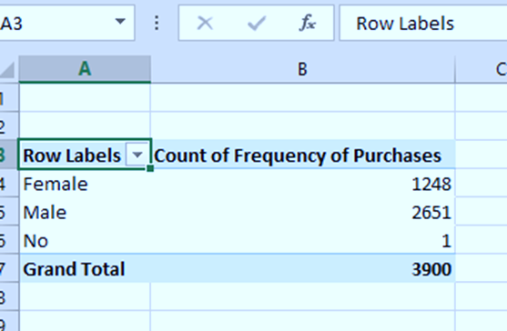

**Question 2:** Which gender prefers using discount?

The table could represent survey results product purchases,or participation data.yes /no might indicates responses or actions taken.The counts could correspond to the number of unique customer meeting each condition.

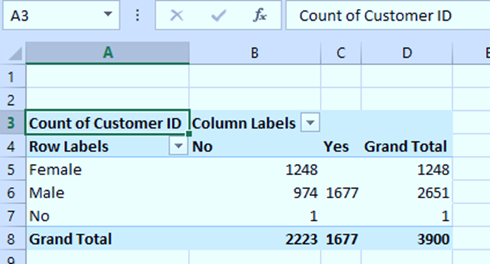

**Question 3:** .Which sizes prefers to purchase by gender?

This dataset likely analyses customer demographics (gender) and their preferences for product sizes. It might be used for inventory planning, marketing strategies,or understanding gender based purchasing trends.

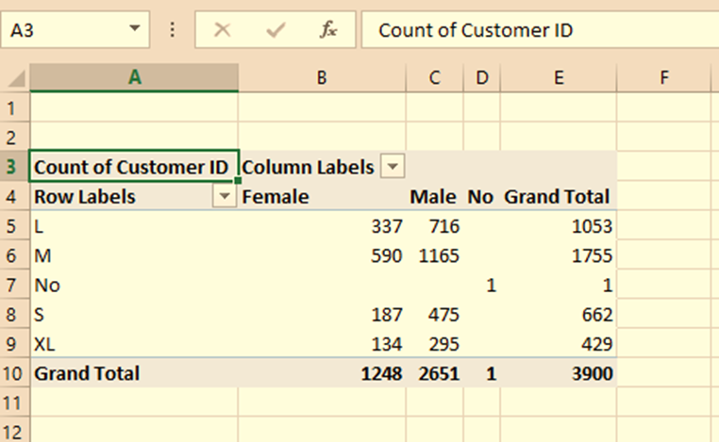

**Question 4**:What is the most popular colours in each season?

Seasonal Analysis: Identify trends in customer preferences for specific categories across seasons.

Category Comparison: Determine the popularity of different color categories.

Customer Insights: Assess total customer engagement or focus on high-performing categories seasons.

Inventory Planning: Predict demand for certain products colors in different seasons based on customer counts.

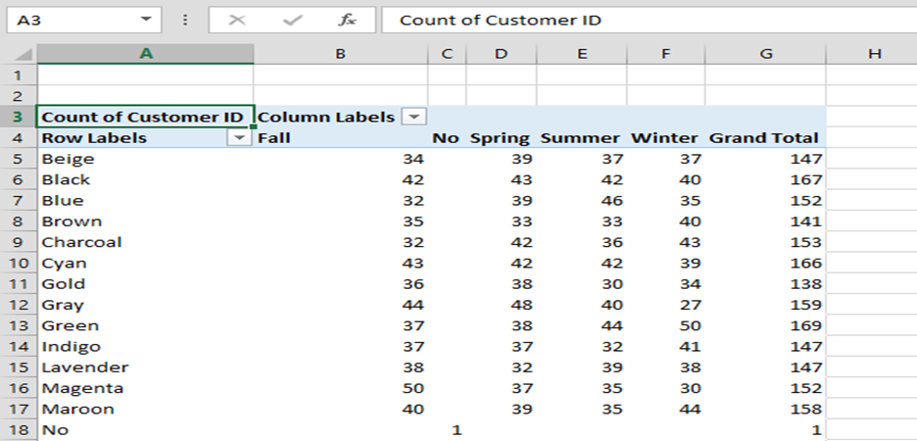

* **Refferences**

1.Brown, T. (2023). The Rise of Digital Payment Methods. Digital Economy Journal, 12(4), 345–360.

2.Deloitte Insights. (2022). Global Consumer Trends. Retrieved from www.deloitte.com.

3.Statista. (2023). E-commerce purchasing behavior by demographics. Retrieved from www.statista.com.

* **Appendices**

**Appendix A:** Survey Questionnaire

A list of all questions used in the customer survey, including demographic and behavior-related questions

**Appendix B:** Statistical Analysis Tables

• Raw data and statistical analysis outputs for purchasing trends by age group.

**Appendix C:** Visuals and Graphs

• Detailed graphs of seasonal purchasing behavior trends for 2022–2023